**INTRODUCTION**

**Aim :**

Introduction to 8085, 8086 Microprocessors & 8051 Microcontroller.

**Theory :**

**8085 MICROPROCESSOR**

8085 is pronounced as "eighty-eighty-five" microprocessor. It is an 8-bit microprocessor designed by Intel in 1977 using NMOS technology.

8085 has the following **configuration** –

* 8-bit data bus
* 16-bit address bus, which can address up to 64KB
* A 16-bit program counter
* A 16-bit stack pointer
* Six 8-bit registers arranged in pairs: BC, DE, HL
* Requires +5V supply to operate at 3.2 MHZ single phase clock
* It is used in washing machines, microwave ovens, mobile phones, etc.

8085 consists of the following **functional units** –

**Accumulator :**

It is an 8-bit register used to perform arithmetic, logical, I/O & LOAD/STORE operations. It is connected to internal data bus & ALU.

**Arithmetic and Logic Unit :**

As the name suggests, it performs arithmetic and logical operations like Addition, Subtraction, AND, OR, etc. on 8-bit data.

**General Purpose Registers :**

There are 6 general purpose registers in 8085 processor, i.e. B, C, D, E, H & L. Each register can hold 8-bit data. These registers can work in pair to hold 16-bit data and their pairing combination is like B-C, D-E & H-L.

**Program Counter :**

It is a 16-bit register used to store the memory address location of the next instruction to be executed. Microprocessor increments the program whenever an instruction is being executed, so that the program counter points to the memory address of the next instruction that is going to be executed.

**Stack Pointer :**

It is also a 16-bit register works like stack, which is always incremented/decremented by 2 during push & pop operations.

**Temporary Register :**

It is an 8-bit register, which holds the temporary data of arithmetic and logical operations.

**Flag Register :**

It is an 8-bit register having five 1-bit flip-flops, which holds either 0 or 1 depending upon the result stored in the accumulator.

These are the set of 5 flip-flops –

* Sign (S)
* Zero (Z)
* Auxiliary Carry (AC)
* Parity (P)
* Carry (CY)

Its bit position is shown in the following table −

|  |  |  |  |  |  |  |  |
| --- | --- | --- | --- | --- | --- | --- | --- |
| **D7** | **D6** | **D5** | **D4** | **D3** | **D2** | **D1** | **D0** |
| **S** | **Z** | **X** | **AC** | **X** | **P** | **X** | **CY** |

### Instruction Register and Decoder :

### It is an 8-bit register. When an instruction is fetched from memory then it is stored in the Instruction register. Instruction decoder decodes the information present in the Instruction register.

### Timing and Control Unit :

### It provides timing and control signal to the microprocessor to perform operations. Following are the timing and control signals, which control external and internal circuits –

### Control Signals : READY, RD’, WR’, ALE

### Status Signals : S0, S1, IO/M’

### DMA Signals : HOLD, HLDA

### RESET Signals : RESET IN, RESET OUT

### Interrupt Control :

### As the name suggests it controls the interrupts during a process. When a microprocessor is executing a main program and whenever an interrupt occurs, the microprocessor shifts the control from the main program to process the incoming request. After the request is completed, the control goes back to the main program.

### There are 5 interrupt signals in 8085 microprocessor : INTR, RST 7.5, RST 6.5, RST 5.5, TRAP.

### Serial Input / Output Control :

### It controls the serial data communication by using these two instructions: SID (Serial input data) and SOD (Serial output data).

### Address Buffer and Address – Data Buffer :

### The content stored in the stack pointer and program counter is loaded into the address buffer and address-data buffer to communicate with the CPU. The memory and I/O chips are connected to these buses; the CPU can exchange the desired data with the memory and I/O chips.

### Address Bus and Data Bus :

### Data bus carries the data to be stored. It is bidirectional, whereas address bus carries the location to where it should be stored and it is unidirectional. It is used to transfer the data & Address I/O devices.

### 8085 ARCHITECTURE :

### C:\Users\alama\Downloads\image1.jpeg

**8085 PIN CONFIGURATION :**

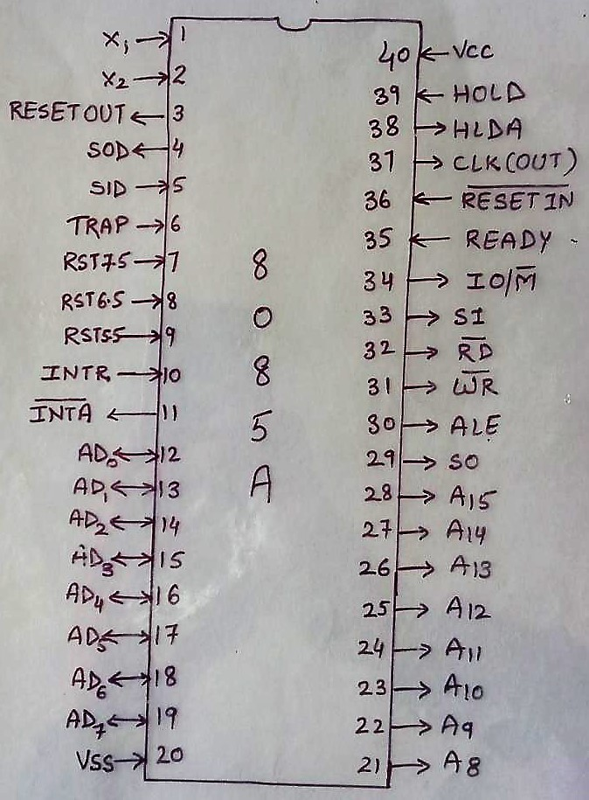

**8086 MICROPROCESSOR**

8086 Microprocessor is an enhanced version of 8085 Microprocessor that was designed by Intel in 1976. It is a 16-bit Microprocessor having 20 address lines and16 data lines that provides up to 1MB storage. It consists of powerful instruction set, which provides operations like multiplication and division easily. It supports two modes of operation, i.e. Maximum mode and Minimum mode. Maximum mode is suitable for system having multiple processors and Minimum mode is suitable for system having a single processor.

The most prominent **features** of 8086 microprocessor are as follows –

* It has an instruction queue, which is capable of storing six instruction bytes from the memory resulting in faster processing.
* It was the first 16-bit processor having 16-bit ALU, 16-bit registers, internal data bus, and 16-bit external data bus resulting in faster processing.
* It is available in 3 versions based on the frequency of operation –
  + 8086 → 5MHz
  + 8086-2 → 8MHz
  + 8086-1 → 10 MHz
* It uses two stages of pipelining, i.e. Fetch Stage and Execute Stage, which improves performance.
* Fetch stage can prefetch up to 6 bytes of instructions and stores them in the queue.
* Execute stage executes these instructions.
* It has 256 vectored interrupts.
* It consists of 29,000 transistors.

**8086 ARCHITECTURE :**

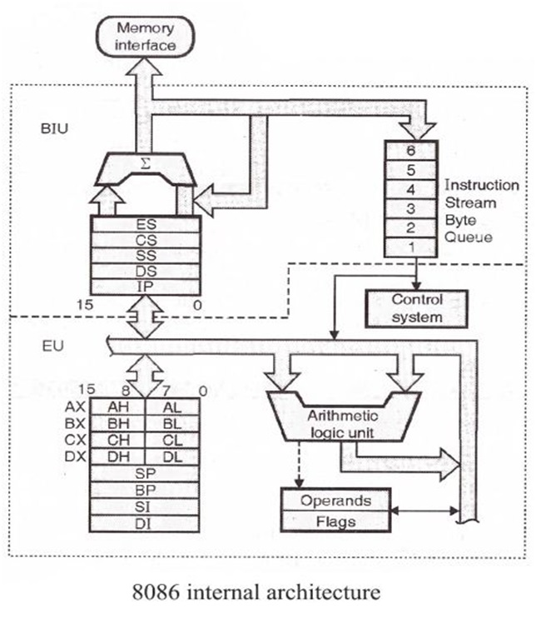

**EU (Execution Unit) :**

## Execution unit gives instructions to BIU stating from where to fetch the data and then decode and execute those instructions. Its function is to control operations on data using the instruction decoder & ALU. EU performs operations over data through BIU.

## **Functional** parts of EU –

## **ALU :** It handles all arithmetic and logical operations, like +, −, ×, /, OR, AND, NOT operations.

## **Flag Register :**

## It is a 16-bit register that behaves like a flip-flop, i.e. it changes its status according to the result stored in the accumulator. It has 9 flags and they are divided into 2 groups – Conditional Flags and Control Flags.

## **Conditional Flags :** It represents the result of the last arithmetic or logical instruction executed.

* **Carry Flag :**  This flag indicates an overflow condition for arithmetic operations.
* **Auxiliary Flag :** When an operation is performed at ALU, it results in a carry/barrow from lower nibble to upper nibble, then this flag is set. The processor uses this flag to perform binary to BCD conversion.
* **Parity Flag :** This flag is used to indicate the parity of the result. For odd number of 1’s, the Parity Flag is reset.
* **Zero Flag :** This flag is set to 1 when the result of arithmetic or logical operation is zero else it is set to 0.
* **Sign Flag :** This flag holds the sign of the result.
* **Overflow Flag :** This flag represents the result when the system capacity is exceeded.

### Control Flags : Control flags controls the operations of the execution unit.

* **Trap Flag :** It is used for single step control and allows the user to execute one instruction at a time for debugging. If it is set, then the program can be run in a single step mode.
* **Interrupt Flag :** It is an interrupt enable/disable flag, i.e. used to allow/prohibit the interruption of a program. It is set to 1 for interrupt enabled condition and set to 0 for interrupt disabled condition.
* **Direction Flag :** It is used in string operation. As the name suggests when it is set then string bytes are accessed from the higher memory address to the lower memory address and vice-a-versa.

### General Purpose Register : There are 8 general purpose registers, i.e., AH, AL, BH, BL, CH, CL, DH, and DL.

* **AX Register :** It is also known as accumulator register. It is used to store operands for arithmetic operations.
* **BX Register :** It is used as a base register. It is used to store the starting base address of the memory area within the data segment.
* **CX Register :** It is referred to as counter. It is used in loop instruction to store the loop counter.
* **DX Register :** This register is used to hold I/O port address for I/O instruction.

### Stack Pointer Register : It is a 16-bit register, which holds the address from the start of the segment to the memory location, where a word was most recently stored on the stack.

### BIU (Bus Interface Unit) :

### BIU takes care of all data and addresses transfers on the buses for the EU like sending addresses, fetching instructions from the memory, reading data from the ports and the memory as well as writing data to the ports and the memory. EU and BIU are connected with the Internal Bus.

## **Functional** parts of BIU –

## **Instruction Queue :**

## BIU contains the instruction queue. BIU gets up to 6 bytes of next instructions and stores them in the instruction queue. When EU executes instructions and is ready for its next instruction, then it simply reads the instruction from this instruction queue resulting in increased execution speed.

## **Segment Register :**

## BIU has 4 segment buses, i.e. CS, DS, SS & ES. It holds the addresses of instructions and data in memory, which are used by the processor to access memory locations. It also contains 1 pointer register IP, which holds the address of the next instruction to be executed by the EU.

* **CS –** Code Segment. It is used for addressing a memory location in the code segment of the memory, where the executable program is stored.
* **DS –** Data Segment. It consists of data used by the program and is accessed in the data segment by an offset address or the content of other register that holds the offset address.
* **SS –** Stack Segment. It handles memory to store data and addresses during execution.
* **ES –** Extra Segment. ES is additional data segment, which is used by the string to hold the extra destination data.

**Instruction Pointer :** It is a 16-bit register used to hold the address of the next instruction to be executed.

**8086 PIN CONFIGURATION :**

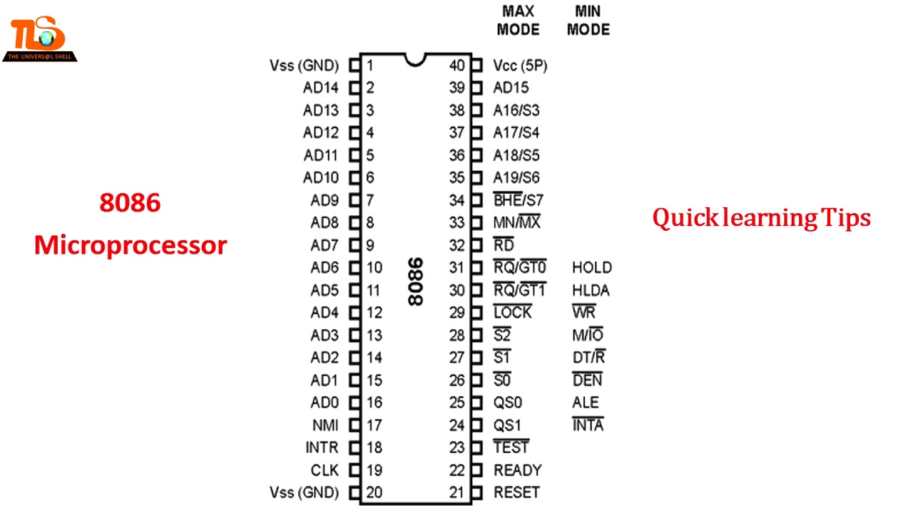

**8051 MICROCONTROLLER**

8051 microcontroller is designed by Intel in 1981. It is an 8-bit microcontroller. It is built with 40 pins DIP (Dual Inline Package), 4kb of ROM storage and 128 bytes of RAM storage, two 16-bit timers. It consists of four parallel 8-bit ports, which are programmable as well as addressable as per the requirement. An on-chip crystal oscillator is integrated in the microcontroller having crystal frequency of 12 MHz

**8051 ARCHITECTURE :**

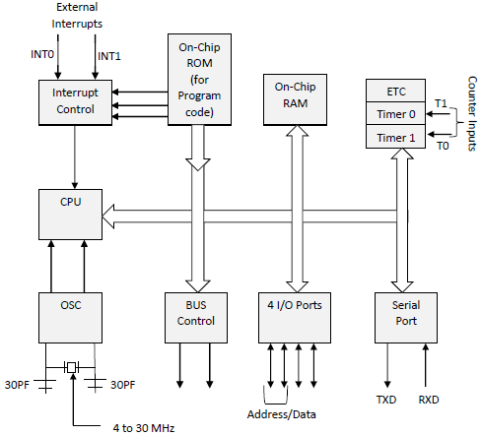

The system bus connects all the support devices to the CPU. The system bus consists of an 8-bit data bus, a 16-bit address bus and bus control signals. All other devices like program memory, ports, data memory, serial interface, interrupt control, timers, and the CPU are all interfaced together through the system bus.

**8051 PIN CONFIGURATION :**

